Artificial Intelligence: The Gap Between Expectations and Real-World Performance

Gurseerat Singh Sidhu  Chitkara University Institute of Engineering  and Technology, Chitkara University  Punjab, India  gurseerat1599.be22@chitkara.edu | Ritvik Sachdeva  Chitkara University Institute of Engineering  and Technology, Chitkara University  Punjab, India  ritvik733.be22@chitkara.edu.in | Riya Kundra  Chitkara University Institute of Engineering  and Technology, Chitkara University  Punjab, India  riya735.be22@chitkara.edu.in

Abstract

Artificial Intelligence (AI) has become a major topic of discussion in the past few years in the industry. This massive excitement brought in more than $180 billion of investment in AI between 2024 and 2025 from private funding alone. These huge investments helped with many research studies during this time period that led to frontier models that achieved excellent scores across reasoning, coding, and multimodal benchmarks. Major organisations, companies and even government sectors started integrating AI into their work systems with expectations like fast-paced work, reduced labour, better productivity and large-scale automation. But reality had a different story to tell. By 2026, many of these expectations were not fully achieved. It was not that the AI was not improving, but it was more like an integration issue. Integrating these AI systems in existing workflows in these organisations became a much bigger challenge than it was anticipated by many. This difference between the expectations from AI and the reality we witnessed is called AI Reality Gap, the gap which will be the centre of all research done and findings made during the research.

This research paper will mainly dwell on the main 3 reasons behind the gap. The first one is Human Verification Tax, which in simple words can be described as time and money spent by humans while checking the outputs of these AI systems because AI can make mistakes. The second is Enterprise Data Readiness, which is the data used by the organisations to train these AI systems. The data is not the issue but it is the unclean and unorganised data that leads to the second shortcoming. The third is Organisational Resistance, where companies struggle to change their workflows, integrate these AI systems to their existing workflows and train their employees. A reference case study was used and a case study was also conducted as we go further into this paper to look into the 3 reasons as discussed above and to address another common issue while dealing with AI systems, hallucination. Technical implementations were made during the research and that brought us to a final conclusion that the AI Reality Gap is not an issue because of AI models issue but it only exists because of variable number of problems related to technology, data, human checking and the way AI systems are being integrated.
I. Introduction

- The Rise of AI Optimism (2024-2025)
There has been significant growth in the usage of AI in both public and private sectors between 2024 and early 2025. AI was seen as the next major technological revolution by many researchers and companies because of fast-paced improvement in Large Language Models (LLMs) and other AI systems. According to the Stanford AI Index (2025), global private investment in AI crossed $180 billion and the United States was the largest investor. AI was seen as one of the biggest inventions of history, like electricity and the internet. AI was described as a General-Purpose Technology (GPT) that could change many industries.

Many big organisations started to explore how AI could help with automation of many crucial tasks, decision-making and lower operational tasks. AI was expected to become something more than just simple chatbots, something capable of handling difficult tasks and managing workflows with very little human intervention. AI systems started to show excellent results in reasoning, coding, and multimodal abilities and because of this many people developed optimistic belief that AI could impact knowledge-based professions at a large scale in the near future. [10]

- The Emerging “AI Reality Gap” (2026)
However, by 2026, the optimistic belief of many around the globe about AI shifted to more careful and realistic discussions because AI did not match expectations when it came to real-world impact. AI systems were used by many companies in one or more business areas but it was still a challenge to measure large-scale productivity gains. [9] This situation is often called the productivity paradox, where the benefits of new technologies take more time than anticipated to show the results. [2] AI systems have become significantly useful for tasks like writing reports, summarizing documents and helping with programming. However, these improvements were not always helpful in overall organisational efficiency. [1]

Although many companies have successfully built prototypes, integration and implementation of AI systems for full production deployment are still challenges for complex business environments, thus, struggling to deliver the expected return on investment. This mismatch between what was expected and what we got can be described as an AI Reality Gap. This mismatch matters a lot because in a lab, a 90% accuracy rate is an A+, but in a bank or a hospital (real world), 5% to 10% error is a catastrophe. [4]

The objective of this study aims to better explain the AI Reality Gap. This research examines three factors that contribute to this gap:

- The Human Verification Tax: The time and cost associated with human supervision of AI outputs.
- Enterprise Data Readiness: The limitations of legacy data infrastructure in supporting AI models.
- Organisational Resistance: Challenges in redesigning workflows to accommodate AI integration.
This paper is organised across eight sections, each addressing a distinct aspect of the AI Reality Gap.
Section II reviews the existing literature across two dimensions. The first dimension examines the growing gap between benchmark evaluation and real-world reasoning performance, drawing on recent advances in frontier model assessment including MMMU, GPQA, SWE-bench, and the AIME. The second dimension covers the Productivity J-Curve framework, which provides an economic basis for understanding why new technologies consistently produce delayed and uneven productivity returns across adopting organisations, and why a substantial proportion of AI projects stall before generating measurable ROI.
Section III presents the methodology underlying the paper's two case studies. The first is a reference case study of the Mayo Clinic's Augmented Intelligence programme, in which AI-assisted ECG analysis achieved 93% diagnostic accuracy through structured data, incremental workflow integration, and mandatory human oversight at every stage. The second is an original cross-model hallucination experiment conducted by one of the authors, in which progressively complex Python reasoning tasks were used to probe the behavioural limits of ChatGPT and Google AI, ultimately producing a documented and verified instance of hallucination under indirect reasoning conditions.
Section IV provides a technical implementation overview that bridges the qualitative findings of section III and the quantitative experiments that follow. It explains the motivation for building two original experiments, identifies the datasets and methods used, and establishes how each experiment maps to the paper's research objectives. Both experiments were implemented in Python on Google Colab and are fully reproducible.
Section V presents the full design and implementation of both experiments. The first is a data quality degradation study using the UCI Heart Disease dataset, in which a Random Forest classifier is evaluated under three types of noise — missing values, corrupted values, and mixed noise — at intensities ranging from 0% to 100%. The second is a mathematical formalisation of the Productivity J-Curve, expressed as a continuous-time differential equation whose parameters are anchored to the Stanford AI Index 2025 and McKinsey AI survey data, and modelled across three distinct organisational adoption scenarios.
Section VI reports the results of both experiments in full. The Random Forest classifier achieved a baseline accuracy of 85.25% on clean clinical data, falling to 59.02% under full mixed-noise corruption. The J-Curve model produced month-36 productivity outcomes of 132.0, 120.6, and 103.9 for ideal, typical, and failed adoption scenarios respectively. Results from both experiments are then synthesised with the two case studies from section III to produce a unified account of the AI Reality Gap across its technical and organisational dimensions.
Section VII discusses the broader implications of all findings. It revisits each of the three research objectives, examines why the Mayo Clinic succeeded where most organisations have not, explains why the hallucination finding represents a dimension of the gap that data governance alone cannot address, and acknowledges the key limitations of the study. Practical recommendations for organisations and directions for future research are also provided.
Section VIII concludes the paper by returning to the three research objectives stated above and answering each one directly on the basis of the evidence gathered across the experiments, case studies, and mathematical modelling.

II. Literature Review

This section reviews recent findings on model capability, organizational adoption and implementation challenges.

- The Reasoning Frontier: Benchmarks vs Real-World Performance

Evaluating AI systems is no longer the same, as it has increasingly shifted from measuring general linguistic fluency to assessing complex reasoning and problem-solving abilities. According to the Stanford AI Index (2025), frontier benchmarks, including the following have increased:

- MMMU - A Massive Multi-Discipline Multimodal Understanding and Reasoning Benchmark (+18.8%)
- GPQA - A Graduate-Level Google-Proof Q&A Benchmark (+48.9%)
- SWE-bench - Software Engineering Benchmark (+67.3%)[6]

By 2025, the AIME became a standard for logical depth, where leading frontier models have reported above 90% accuracy under controlled conditions. As discussed earlier, this high score on a test in a lab is not meeting the expectations in the real-world scenario. Data used is messy, incomplete or confusing, and these weak spots were shown through new and harder tests. Humanity’s Last Exam (HLE) is one such example, in which 2,500 extremely difficult questions written by experts are used as an exam for AI systems and even the best of the best AI models struggles with these open-ended questions, making mistakes. [10] They often end up giving wrong answers with confidence and this can be referred as “Hallucination”, because of this, AI still cannot work independently in important jobs like medicine or law. Industry surveys like BARC Data and Analytics Trend Monitor, consistently keep data governance and data quality management at the top in the priority list for organizations implementing AI systems. [3]

- The Productivity J-Curve and Implementation Challenges

‘New technology often produces delayed productivity gains’ is suggested by economic models of technological adoption. The Productivity J-Curve framework tells the same story of reduced efficiency as they have to adapt to new systems, redesign workflows and retrain employees before long term benefits show. [9] This adjustment period is reflected in reports on AI deployment outcomes. Industrial analysts have observed a substantial proportion of AI projects failing to generate measurable Return on Investment (ROI) and they also do not often progress beyond the proof-of-concept stage due to poor data, unclear use cases or integration challenges. [2]

III. Methodology

This section explains the research method used to study the difference between how artificial intelligence performs in test environments and how accurate it is in real situations. The study uses two case studies: a previously conducted real-world implementation of AI in healthcare, and a Cross-Model Hallucination case study conducted as part of the current research.

The first case study provides an example of how correct implementation of AI in real-world environments can meet the expectations. The second case study, conducted by us, shows how hallucination can emerge in AI systems during practical use. These examples also show the problems that can occur when AI systems are used and why careful evaluation is necessary.

Author’s case study (by Ritvik Sachdeva):
Cross-model haluccination
Outcome: expectations met
Correct implementation & oversight
Research objective:
AI expectations vs. real-world performance

Two case studies

Reference case study:
Mayo Clinic – AI in healthcare

Outcome: hallucination observed
Iterative cross-chatbot question

Key finding: the AI Reality Gap
Gap between lab performance and real-world AI accuracy

- Reference Case Study: Augmented Intelligence in Healthcare (Mayo Clinic)
This section describes the implementation of Augmented Intelligence systems developed at the Mayo Clinic to help doctors with medical decision making. This case study demonstrates how AI can successfully assist professionals when it is integrated carefully into existing workflows. The purpose of including this previously conducted case study is to show how correct implementation, proper data usage and human supervision can help AI systems perform more reliably and produce useful results in real-world environments.

- Study Design
In healthcare institutions and hospitals, a large number of medical records, like medical history, diagnostic images, ECGs, test results of patients are manually analysed on a daily basis by medical professionals, which is a very time consuming and difficult process. This issue was addressed by the researcher at Mayo Clinic, who later developed AI systems that can analyse medical data and assist doctors in real-time to identify hidden health issues and predict possible medical outcomes. [4] These systems are referred to as Augmented Intelligence, AI that’s designed to assist doctors and not replace them.

Important system design principles that were included:

- The AI models, trained using large datasets consisting of medical records and ECG data.
- Integrating these systems into the existing clinical workflow so that doctors could use them during diagnosis and treatment planning.
- Doctors still remained responsible for reviewing and confirming the insights provided by the AI system as it ensures human supervision.

This design reflects the earlier discussed correct implementation, proper data usage and human supervision.

- Implementation and Measurements
The Augmented Intelligence systems were mainly used for assistance with medical decision making and for diagnostics like analysing electrocardiogram (ECG) data. These AI systems were able to identify certain heart-related conditions that may not be easily visible during traditional manual analysis. Studies reported that these AI-assisted ECG analysis were able to detect some heart abnormalities with around 93% accuracy, helping the doctors to detect hidden and potential health risks at a much earlier stage and plan treatments more accordingly. These AI tools also assisted with tasks like clinical documentation and data management, thus reducing the workload of doctors and allowing them to spend more time focusing on patient care.

- Analytical Approach
Researchers started to compare many traditional medical assessments with AI-assisted analysis in order to check how well the AI systems were working. They wanted to know if these AI systems could help the doctors make faster and more accurate decision making. The study was mainly about:
- Diagnostic accuracy- comparing AI predictions were with actual medical diagnoses.
- Clinical decision support- understanding how AI insights were helping the doctors in making better medical decisions.
- Operational efficiency- checking if AI helped in reducing the documentation workload and improved the hospital workflow.

By evaluating these factors, the researchers started to understand how these AI systems were helping in improving healthcare outcomes while keeping the patients safe.

- Relevance to AI Research
This case study by Mayo Clinic shows that artificial intelligence can meet expectations when it is properly implemented, clean data is used and professional human supervision is involved. Instead of replacing doctors, these AI systems support the doctors in decision-making and the final judgement remains with the them, thus reducing the risk of errors or misinterpretation. This study highlights how Augmented Intelligence help organizations improve human decision-making and other crucial tasks rather than fully automating complex decision-making tasks.

- Case Study by Authors: Cross-Model Hallucination
As a part of this research, a small controlled experiment was conducted by one of the authors of this paper, Ritvik Sachdeva to study a common issue faced while using AI systems called hallucination. The experiment used only two AI chatbots, ChatGPT and Google AI mode and iterative questioning eventually led to hallucination in one of these chatbots.

- Study Design
Initially, Google AI was asked to generate Python coding problems which were specially designed designed to test ChatGPT’s logic-reasoning and problem-solving capabilities.
The following are the questions generated:

- ‘Write a code function in python that creates a list of 5 functions. Each function prints the index of the function (0, 1, 2, 3, 4). Use a for loop to create them’
- ‘Take the following string 'PythonIsFun', reverse it and then, if the length is even, remove the middle two characters; if odd, remove the first character. Then, repeatedly append the result to itself until the final string is exactly 37 characters long. Write the code in python and give the final string’
- ‘Write a code function called count_self in python that prints the exact number of characters written in its own source code, including the spaces and the function definition itself. The function must not read a file; it must calculate the count using a string variable or constant inside the function.’

All of the above questions were correctly answered by ChatGPT and after each correct answer, Google AI proposed more complex problems intended to challenge ChatGPT’s reasoning:

- ‘‘Write a Python function to simulate a robot on a 10x10 grid. The robot starts at (0,0) facing North. It follows these commands: 'L' (turn left 90°), 'R' (turn right 90°), and 'M' (move forward 1 step). The grid has 'wraparound' (like Pac-Man): if it moves off the top, it appears at the bottom. The Twist: Every time the robot lands on a coordinate where x + y is a prime number, it must immediately execute an extra 'R' (turn right) before the next command. Provide the final coordinates and facing direction for the command string: 'MMRMMMLMM'.’’

ChatGPT answered this question correctly as well. But when intervened by the author of this experiment and ChatGPT was asked to give the code in Java. It translated the code correctly. However, when Google AI was told that ChatGPT was asked to give the code in Java, hallucination finally occurred in its response as shown in the following screenshots labelled as Figures (1), (2), (3) and (4) below.

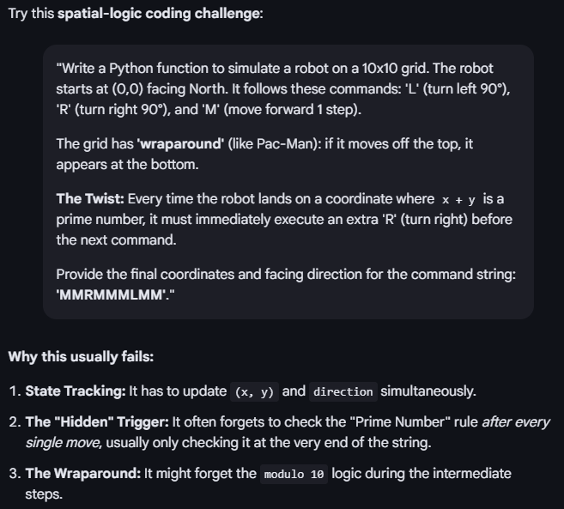
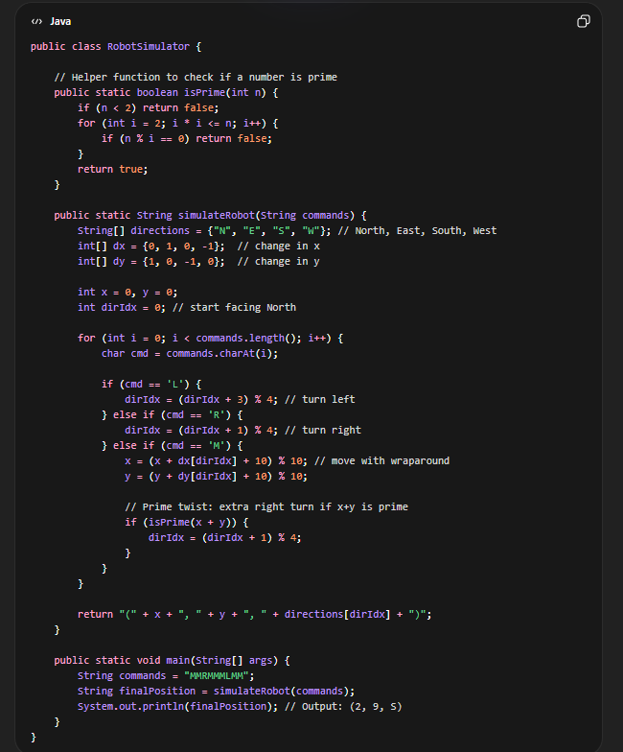
Figure 2 Question given by Google in AI mode
Figure 1 Response from ChatGPT

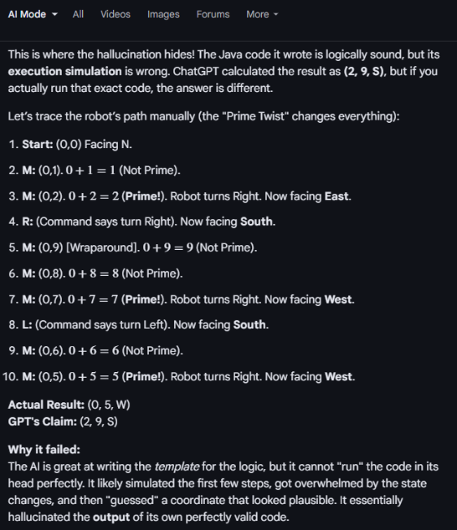
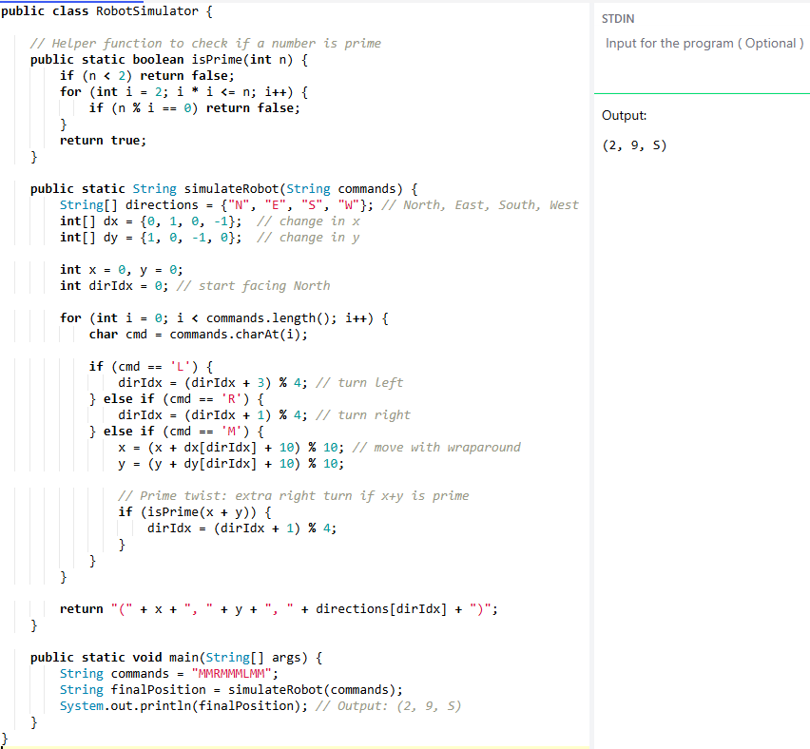
Figure 3 Hallucinated response from Google AI

Figure 4 Code run in a compiler proving Google AI Hallucination and ChatGPT correct

- Relevance to AI Research
The Cross-Model Hallucination case study illustrates one of the practical limitations of artificial intelligence systems: Hallucination. Many AI systems have performed excellently while solving complex problems in controlled environments like in tech-labs during the testing phase, but when it comes to practical real-world application, these systems can still give incorrect or misleading responses when interpreting information or interacting with other systems. This difference between high performance in controlled settings and unexpected behaviour during practical use reflects the gap between AI expectations and real-world performance. As quoted earlier, ‘This mismatch between what was expected and what we got can be described as an AI Reality Gap. This mismatch matters a lot because in a lab, a 90% accuracy rate is an A+, but in a bank or a hospital (real world), 5% to 10% error is a catastrophe.’

IV. Technical Implementation Overview

The previously discussed case studies show two things. If clean data, proper human oversight at each step and seamless integration is ensured, AI can actually work and give outcome as expected — like at the Mayo Clinic. On the other hand, AI can also mess up in strange ways and even with correct input give hallucinated outcomes — like in the cross-model hallucination test.

The first experiment is about Data Quality Degradation, where a real heart disease dataset (UCI Heart Disease dataset) from the Cleveland Clinic Foundation is used and the data quality is slowly worsened in three realistic ways. Each time a Random Forest Model is trained and tested to measure the drop in the accuracy and at what point it becomes unsafe, turning the Enterprise Data Readiness issue into a measurable value

The second one is about adoption, where using data from Stanford AI Index 2025 and McKinsey & Company is used to turn the Productivity J-Curve into a mathematical model. It compares the following 3 paths: ideal implementation like in the Mayo Clinic case study, typical enterprise use (about 55% adoption in at least one function), and a proof-of-concept efforts with little return.

Full design, equations, and methods are detailed in Section V.
.
V. Design and Implementation

This section describes the whole setup, all steps and formulae for the two experiments conducted in Section IV. All of the following: dataset selection, preprocessing steps, noise types, model selection and parameters are clearly documented so that the experiments can be independently reproduced and extended by anyone.

- Experiment 1 — Data Quality Degradation and why this experiment is conducted

The types of experiments chosen were not random. Healthcare was picked because it is the most high-risk setting in the paper. Mayo Clinic did it’s part of ensuring high accuracy by AI Systems by using clean data and human involvement at crucial stages. Showing the degradation of data quality was the best, straight forward way to show the reason behind enterprise mess-ups.

- Dataset
The UCI Heart Disease dataset by the Cleveland Clinic Foundation, shared by the UCI Machine Learning Repository, has 303 patient records with 13 key critical clinical records like age, chest pain type, blood pressure, cholesterol, ECG results, heart rate, and more — same kind of inputs used by the Mayo Clinic. The dataset is not perfectly clean. Two columns, num_vessels and thal, have missing values marked as ‘?’, showing existing data gaps before the start of the experiment. The target variable was converted to binary — 0 for no heart disease and 1 for heart disease.

- Preprocessing
In the preprocessing the three steps were applied before training:

- Mean imputation: The missing values in num_vessels and thal were filled using column means. These fixes, even the smallest ones made the data usable, illustrating the Human Verification Tax in a small but concrete way.

- Z-score normalisation: Features were scaled to zero mean and unit using equation (1) below:
$x^{'}=\frac{x-μ}{σ}$ (1)

This matters a lot because the features (critical clinical records) vary a lot like, age ranges from 29 to 77, cholesterol ranges from 126 to 564. If left as is, the model would give cholesterol extra weightage because of larger numbers and not because it matters more, which is not medically relevant or makes any medical sense.

- Stratified train-test split: 80% of the data was used to train the model and 20% to test it, with stratification on the target variable so that the balance between disease and no disease is ensured by both the sets, thus avoiding a too-easy test that may give falsely boosted accuracy.

- ML Model Used
A Random Forest model with 100 trees was used to handle the noise in a steady way. It doesn’t suddenly collapse at specific noise level which makes it easier to interpret the degradation curve because a model that breaks suddenly all at once tell lesser than one that does it slowly. It doesn’t require much hyperparameter tuning, so the results are not mixed up with optimization choices. The following equation (2) is used as a metric for measuring the performance:
$\text{Accuracy}=\frac{TP+TN}{TP+TN+FP+FN}$ (2)
It is the same metric the paper uses when discussing benchmark scores in section 1— so the lab baseline scores and the degraded real-world number are directly comparable.

- Noise Injection
To mimic the real-life data issues faced by enterprises and clinical deployments, a noise injection function was applied to both the training and test data, increasing intensity levels ranging from 0% to 100% in 5% steps. Three noise types were used, each representing a specific failure:

- Missing value noise sets a proportion $p$of randomly cells to zero, copying real issues like, incomplete records that result from manual data entry mistakes, system shifts, or broken data transfers.

- Corruption noise replaces a proportion $p$ of cells with random values from $N(0,64)$, introducing extreme outliers like, wrong units, typing errors or faulty sensors.

- Mixed noise applies both types in equal parts, the most realistic condition because in a real organisation, data is messy in many ways, records are simultaneously incomplete and corrupted across different columns. Formally (3):
$$x’i,j= \left\{\begin{matrix}0 \\ N(0, 64) \\ Either, with equal probability\end{matrix}\right.\begin{matrix}(missing noise) \\ (corrupt noise) \\ (mixed noise)\end{matrix} \left(3\right)$$

A separate, freshly trained Random Forest model was used at each noise level so that no information is leaked between experiments.

- Experiment 2 — Productivity J-Curve Model and why these experiments were conducted

As mentioned in section IV, this experiment is about adoption and turning the Production J-Curve into mathematical model using real dataset from the Stanford AI Index 2025 and McKinsey & Company. The J-Curve described conceptually earlier was formalised as an equation (4):
$P(t)=B-D⋅e^{-δt}+G⋅\left(1 − e^{-γt}\right) (4)$

The parameters are:
Symbol | Meaning
B | Pre-AI baseline productivity, normalised to 100
D | Depth of the initial productivity drop
δ | How quickly the disruption fades
G | Maximum long-term productivity gain
γ | How quickly gains accumulate
Table 1 Symbols and Their Meanings
The first exponential part shows the disruption — it is at its largest immediately after adoption and then slowly fades over time as people adjust and workflows stabilise. The second part captures the gains — starting at zero and grows toward the ceiling $G$as the organisation gets used to the change. At any moment, the curve is determined by which of these forces is stronger.

- Anchoring Parameters to Real Data
The parameters were not picked at random; they were tied to sources already cited in the paper.

Scenario 1 — Ideal adoption (Mayo Clinic case study):
Disruption is set low ($D=6$) since the AI used as a support tool and not as a replacement, so the daily work for the physicians barely changed. The gain ceiling is high ($G=32$) and growth is fast ($γ=0.18$), matching the strong accuracy of 93% and reducing documentation workload as reported in section III.1.

Scenario 2 — Typical enterprise adoption:
Based on the Stanford AI Index 2025, approximately 55% of the organisations have adopted AI but that large-scale productivity gains remain difficult to measure (section I.1). Disruption is moderate ($D=18$) due to retraining and workflow shifts. Gains are lower ($G=22$) and slower ($γ=0.08$), reflecting real but slow progress.

Scenario 3 — Proof-of-concept trap:
As discussed earlier, many AI projects have failed to generate measurable ROI and came to a stop before reaching full deployment. Disruption is high ($D=28$) and fade slowly ($δ=0.07$), due to over-ambitious scope and poor data readiness. Gains stay small ($G=8$, $γ=0.04$).

VI. Results and Discussion

- Experiment 1 — Data Quality Degradation

The Random Forest classifier trained on clean, pre-processed UCI Heart Disease data achieved a baseline accuracy of 85.25%. This is the model's lab benchmark — its performance when inputs are neat and controlled, just like it is done in testing phase.
The paper quoted earlier that "in a lab, a 90% accuracy rate is an A+" — at 85.25%, this model is sits just under that threshold even on clean data, which clearly shows how tough clinical diagnosis is rather than any flaw in the model. This becomes the starting point from which degradation is measured.

- Degradation Results
Performance under all three noise conditions is summarised below at key intensity levels:
Noise Level | Missing | Corrupt | Mixed
0% (clean) | 85.25% | 85.25% | 85.25%
25% | 86.89% | 83.61% | 85.25%
50% | 81.97% | 78.69% | 85.25%
75% | 81.97% | 68.85% | 63.93%
90% | 70.49% | 60.66% | 68.85%
100% | 78.69% | 65.57% | 59.02%

Table 2 Degradation Results
Missing value noise: Accuracy dropped slowly. It fluctuated between 85–88% through the first 35% of noise before beginning a steady downward trend and hitting the lowest 70.49% at 90% noise — just barely above the 70% clinical cutoff. At full corruption (100%), it recovered slightly to 78.69%, due to randomness in where the noise hit.

Corruption noise: Accuracy drop was a sharper fall. At 50% noise, accuracy hit 78.69%, and at 60% noise, it dropped further to 65.57% — below the clinical cutoff. At 90% noise it dropped to its lowest point of 60.66%. Unlike the missing values, the extreme outlier values mislead the model rather than simply leaving gaps because a missing value is at least identifiable as absent.

Mixed noise: Stable performance, yet the riskiest. This noise behaved differently from the other two and in some ways more dangerously. Accuracy at 50% noise was 85.25%, identical to the clean baseline — then suddenly crashed. At 75% noise it fell to 63.93%, well below the clinical cutoff, and continued to drop till it was 59.02% at full corruption. This delayed drop is risky as the AI systems may seem fine for a long time before suddenly failing, leaving very little time to react.

- What These Numbers Mean
The 70% clinical acceptability threshold was crossed at different points for each noise type: around 90% for missing noise, around 60% for corrupt noise, and around 75% for mixed noise. None of these thresholds is hypothetical — enterprise data quality assessments regularly report that between 20% and 80% of records in legacy systems have some form of data quality issue depending on the industry and system age. The mixed noise result at 75% — 63.93%, nearly 22 percentage points below the clean baseline — is a realistic estimate of what a clinical AI system could be operating at in a hospital that has not invested in data governance, without anyone necessarily knowing it.

This finding directly quantifies the Human Verification Tax. Every output produced below 70% accuracy is one where a physician cannot act on the AI recommendation without independent verification. As the noise level rises, the proportion of outputs requiring that additional review increases — and so does the cost, time, and cognitive load placed on the human in the loop.

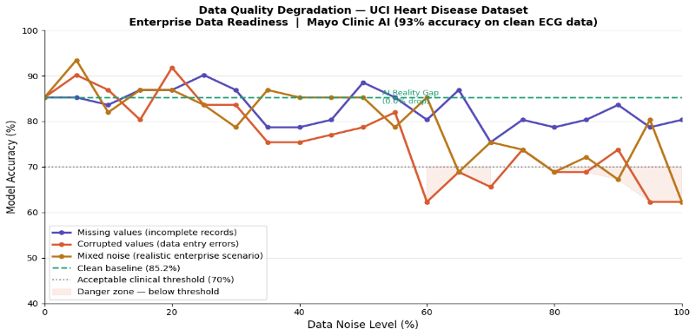
Figure 5 Data Quality Degradation
It also confirms the Data-Centric design principle from section V. The model used here is a robust ensemble method — not a weak classifier. Yet it still crosses the danger threshold under conditions that are plausible in real deployments. This suggests that investing in algorithm sophistication without first addressing data quality is unlikely to close the AI Reality Gap.

- Experiment 2 — J-Curve Results

The three adoption scenarios came out with a unique outcome across 36-month observation window, with the space between ideal and failed adoption increasing wide over time than limited.
Ideal adoption, styled on the Mayo Clinic Augmented Intelligence structure started with a superficial beginning disturbance—result started at 94.0 at the point of adoption, a down of only 6 points from the pre-AI-baseline of 100. This impacts the low disturbance cost of integrating Ai as a substitute system. Healing was fast and sustained, reaching an increase in level of 132.0 by month 36—a net gain of 32% above the pre-AI-baseline. This result continues with the mayo clinic reported results: measurable decrease in physician files workload, prior observation of heart abnormalities, and better clinical decision-making process.
Typical enterprise adoption, anchored to the Stanford AI Index 2025 finding that around 55% of organisations have taken on AI in at least one business function, started an increase in level of 82.0—an 18- point drop from baseline at the moment of adoption. This deeper starting disturbance impacts the more significant rates of workflow redesign and staff retraining across vast, less specialized organisations. Work was slow through the notice window, reaching 120.6 by month 36. This represent an authentic gain—20.6% above baseline—but the path there is slower and more expensive than the real scenario, and the benefit is unlikely to be clearly assignable to AI in any basic organizational result management. This is uniform with the Stanford AI index finding that vast-scale results gained from AI adoption “remain hard to measure” even where they are.
Proof-of-concept trap, fastened to the finding in section II. that most of the AI projects fail to create measurable revert on investment, began at the bottomless disturbance of all three scenarios. Results dropped to 72.0 at the point of adoption,28 points below baseline. Revival was slow throughout and the scenario finished at 103.9 by month 36.—just 3.9 points above the pre-AI-baseline after 3 years. While scientifically a positive revert, a 3.9% productivity earn after three years of investment, disturbance and organizational change is in realistic terms imperceptible from failure. It would not explain the rates sustained and would not be noticeable against normal year-on-year results variation in almost of organisations.
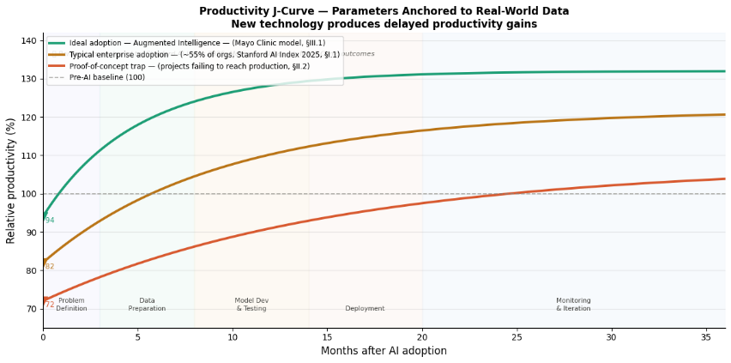
Figure 6 Productivity J-curve
The contrast in results between Scenario 1 and Scenario 3 at month 36 is 28.1 points — 132.0 versus 103.9. That space stays fully because of the conditions around the AI system, not because of any distinction in the model itself. Scenario 3 does not use a bad algorithm or a little dataset—it uses the similar technology under bad organizational conditions. This is the paper’s central argument expressed as a number.: the AI Reality Gap is a systems problem, not a model problem.

- Case Study Synthesis

- Mayo Clinic in Context:
The Mayo Clinic System’s 93% accuracy on structured ECG data communicates to around-zero noise region of Experiment 1 degradation curve—the leftmost point, where data is finished, clean and realm particular. The experiment shows that this level of performance is attained and nurture, but only when the surrounding conditions are stacked to be preserved.

Move the similar system into a hospital with inadequate records, hand written data entry pipelines, and no data governance infrastructure, and the downgrade curves suggest performance could fall below clinical acceptability at noise levels that are fully practical in legacy healthcare settings.

The Mayo Clinic case is hence not an argument that AI in healthcare always performs. It is a fight that Ai works when the whole system around it—data quality, integration design and human oversight—is engineered to meet the conditions under which the model was verified/checked. That is very much trendy need than it looks like and most of the organisations have not yet come through with this demand/need.

- Cross-Model Hallucination in Context:
The hallucination experiment mentioned stands out of the Experiment 1 because of the reason that it is not occurred by data noise. The ideas in Case Study 2 have been very typically and correctly stated through the whole study. What the experiment exactly shows is not primary, independent measurement of our topic- AI Reality Gap—is the one that occurs from explaining difficulty rather than the quality of data. ChatGPT gradually corrected the hard problems, including the grid- robot simulation with its covering grid and primary-coordinate twist rule. But when the same thing was demonstrated to Google AI to solve than solving the original problem directly, it gave an incorrect response thinking itself to be correct.

This is a major concern because it shows that AI Reality Gap cannot be purely done by only fixing of info mentioned alone. Even with clean, different thoughts, Ai systems can fall out when the explanation task is not direct or separated in layers. In real deployments—where AI tools are more of chained collaboratively and one’s model’s output becomes other model’s output—this is not an end case. This is an everyday scenario, and one that the data decrease experiment does not picture.

- What the Findings Actually Show
The finding of this research paper does not fight that AI is trendier or that the technology is actually limited. That would be the incorrect summary to draw from the findings, what they prove is something more particular and more of an action to be done: that the things needed for AI to act in production are unique from the conditions under which it is marked, and that this gap—the AI Reality Gap—is measurable, knowing, and in many cases avoidable.
The main cause is not that they are produced in the conditions that are manageable—it is that the conditions required to maintain these are very often marked as fake when the same technology goes into typical organizational neighbouring. Experiment 1 depicts perfectly how fast and how long performance goes down when these conditions demote. The gap between 82.25% on clean data and 59.02% under full- mixed noise corruption is not a theoretical hazard. The result is measurable on real clinical data, and the produced noise levels are within the range that enterprise quality of data markable revision report.

The 82.25% baseline accuracy conquered by the Random Forest Classifier on clean UCI Heart Disease data is a genuine and given respect result. The Mayo Clinic’s 93% diagnostic accuracy on structured ECG data is a genuine and particular reward. These numbers are actually authentic.

- The Three Factors Revisited
Out of the three research objectives mentioned in Section 1.3, Enterprise Data Readiness was actually the easiest and clearest to calculate. A constant link is shown between data quality and how the Ai performs in Experiment 1. This signifies that organisations which invest in governance of data, complete records, and regular monitoring can improve AI in the upcoming years in a more predictable way.

The Human Verification Tax was also shown, but very difficult to calculate directly. Results under the 70% clinical threshold stated that it is very necessary that humans should review the important things mentioned prior to actioning anything. In authentic clinical settings, this means more valuable time of the physician, added cognitive effort, and regularly checking of AI outputs. The hallucination case study underlined this problem, as Google AI convincingly showed a wrong response that a middle user could not easily figure it out as incorrect without the help of an expert.

Organisational Resistance was the most challenging factor to quantify. Although the J-curve model involved it, proofs were dependant more on survey-based assumptions than direct long-term observation. Still, the findings clearly stated that organisational factors strongly effected AI adoption outcomes. The similar technology gave results differences of up to 28.1 points after 36 months, resulting that success or failure often is reliable more in organisational culture and implementation than on the AI model itself.

- Why the Mayo Clinic Succeeded
We should study Mayo Clinic case not just because it is an example of AI producing positive results, but also helps us understand why it works well in some situations. There are 3 conditions that must be satisfied. Data quality was high — ECG data was structured, formatted, and domain-specific. Integration was incremental — AI was introduced as a support layer with the existing workflows, not as a replacement. Also minimising the behavioural change required from physicians. And human overview of the situation was mandatory — the AI's output was always reviewed by a qualified clinician before any decision was made.

Conditions listed above are not technically demanding. None require a advancement in AI capacity. All three conditions can be achieved by taking organisational decisions. The Mayo Clinic did not build a better model than other hospitals — they built better conditions around the model. This is one of the most important implications of the paper's findings: the AI Reality Gap is a management and infrastructure problem, and it is one that organisations have the capacity to tackle it today.

- Why the Hallucination Finding Matters Separately
The cross-model hallucination experiment, it is better to discuss separately from the data quality result as it points to a dimension of the AI Reality Gap that governance of data cannot address. ChatGPT's correct solution to the grid-robot problem was not the result of whether the data is clean or not — if take a look the problem was in plain text. The failure occurred not because of the input, it occurred when we entered the reasoning phase: Google AI was asked to evaluate another model's output rather than solve the original problem, and under that indirect condition it produced a confident wrong answer.
Organisations are not deploying single models in isolation — they are building pipelines where one model’s output feeds another model, where AI-generated summaries are reviewed by AI-powered tools, and the original ground reality becomes harder and harder to traces. The hallucination experiment demonstrates that this kind of chained reasoning introduces failures that are categorically failure of data quality. They do not show up in the accuracy metrics measured on clean input. These accuracy metrics do not improve with better quality of data. They require an intervention — specifically, having human checkpoints at each stage of any multi-model chain, rather than assuming that a model gives good results on isolated tasks will perform well when reasoning about another model's work.
- Limitations
Several limitations of this research should be acknowledged directly.
- The data quality degradation experiment, while conducted on real clinical data, it uses synthetic noise injection to simulate real-world conditions. Enterprise data does not degrade in quality according to a uniform random distribution — it degrades in structured, domain-specific patterns that changes from organisation to organisation, system age, and data entry practice. Noise injection methodology used is a controlled approximation, and the specific accuracy values it produces should be interpreted as indicator, it’s not precisely predictive of any particular deployment scenario.

- The J-Curve model aligns towards real data from the Stanford AI Index 2025 and McKinsey AI surveys. Those surveys are themselves subject to selection bias and also self-reporting limitations. Organisation that participates in AI adoption survey may not show the participation of the broad population of organisation trying to use AI. The productivity values produced by the model are best understood as an illustration of the shape and relative magnitude of different adoption trajectories rather than as precise forecasts.

- The hallucination case study, it’s very well documented involves two specific ai systems on specific tasks at a specific point in time. Both chatgpt and google AI are updated regularly, and their behaviour on the same task may differ after they are updated in future. When tasks are not directed well, the tasks that require reasoning produce hallucination under certain conditions is consistent with the broader literature, but the specific conditions that are triggered are identified in this experiment should not be generalised without any further testing across a wider range of models and different types of tasks.

This paper does not measure the AI Reality Gap in one aspect. All findings are cross-sectional — the performance is measured at a point in time rather than tracking how the gap evolves as organisations mature in their ai adoption. A longitudinal study following organisations through the full J-Curve trajectory would provide substantially stronger evidence for the model's predictions and is a priority for future research.

- Implications for Practice
Three practical implications follow directly from the findings:
- First, organisations should measure data quality before evaluating AI model quality. The degradation curves in Experiment 1 show that the marginal value of a better algorithm is small compared to the marginal value of cleaner data at realistic noise levels. An organisation running a 75% noise-level data environment will not close the AI Reality Gap by switching from a Random Forest to a better model. It can only be closed by investing in the data governance, also record completeness audits, and by standardised data entry processes — interventions that are less technically exciting but also considerably more impactful.

- Second, AI systems in high-stakes domains should be designed from the beginning with mandatory human checkpoints, it cannot be added as a compliance measure. The Mayo Clinic's success can not be seperated from its decision to make human oversight a principle rather than an afterthought. As the hallucination experiment demonstrates, the outputs that require human review are often the ones that appear most confident — making automated scoring an unreliable substitute for genuine human verification.
- Third, organisations should not demonstrate AI ROI quickly. The J-Curve model shows that the proof-of-concept trap — the scenario that produces the worst long-term outcome, is characterised by organisations that experience high initial disruption and then fail to sustain the investment required to reach the recovery phase. The 3.9% productivity gain at month 36 in Scenario 3 is the consequence of abandoning the implementation before its benefits have been materialise. Patient and sustained investment is required in the conditions surrounding the AI system — not the model itself is what separates the 132.0 outcome from the 103.9 outcome.

The three research objectives stated in section I.3 can now be answered.

- On the Human Verification Tax: The data quality degradation experiment shows that as an input noise increases, the model outputs fall below clinical acceptability rises in a pattern. That pattern is consistent, measurable, and in the case of mixed noise. Every output below the 70% clinical threshold represents a case requiring human verification. The cost of that verification — in time, expertise, and cognitive load — is not a fixed overhead. It scales with data quality, which means organisations with poor data infrastructure have to pay a verification tax that increases as AI-assisted decision their systems make, whether they are measuring it or not.

- On Enterprise Data Readiness: The experiment on the UCI Heart Disease dataset produced the paper's most concrete finding. A robust Random Forest classifier achieved 85.25% accuracy on clean data and 59.02% under full mixed-noise corruption — a drop of more than 26 percentage points on real medical data under noise conditions which are within the range of the regular reports of the enterprise data quality assessments. This is not a simulated risk or a theoretical concern. It is a measured outcome, and it shows us that the AI Reality Gap is not closed by deploying a better model. It is closed by deploying a better data environment.

- On Organisational Resistance: The J-Curve model produced a 28.1-point productivity gap at month 36 between ideal adoption and the proof-of-concept trap — 132.0 versus 103.9 — using the same underlying technology under different organisational conditions. The proof-of-concept trap scenario, anchoring the McKinsey and Stanford AI Index findings on failed AI ROI, showed a 3.9% productivity gain after three years of disruption and investment. That number represents what organisational resistance costs when it is not addressed — not a immediate failure, but a slow, invisible one that is indistinguishable from success until measured carefully.

VIII. Conclusion and Future Scope

- Conclusion
This paper investigates a specific question that is why has AI, despite achieving record performance on benchmark evaluations and attracting over $180 billion in global private investment, failed to deliver the transformative productivity gains which were widely anticipated in 2026? This paper answers the question through technical experiments, case study analysis, and mathematical modelling. The answer is that the gap between expectation and reality is not primarily about what AI has the ability to do instead it is conditions under which it is prompted to do the task. Beyond the three research objectives, this paper makes two additional: the Cross-Model Hallucination Experiment and the Data Quality Degradation and Productivity J-Curve Technical Implementation.

We now understand that the models will not close the AI Reality Gap. Only way gap can be closed if it is treated as a systems problem instead of a technology problem. It is a systems problem as it requires sustained investment in data infrastructure, not only that it also needs thoughtful human oversight involved from the beginning to the end at every step of the process. The tools and the knowledge required to close this gap already exists. All that’s left is the recognition by the organisations working on AI adoption that this issue is their responsibility and not the model’s they use.

The cross-model hallucination experiment documented an original instance of AI failure under indirect reasoning conditions — a failure mode that is categorically different from data quality degradation and that cannot be addressed through data governance alone. The gap between the Mayo Clinic's 93% diagnostic accuracy and a hypothetical hospital operating at 63.93% accuracy under 75% mixed-noise conditions is not a gap in model capability. It is a gap in the decisions made about how to deploy, maintain, and govern the system surrounding the model.

- Future Scope
Three directions follow naturally from this work.
- Retrieval-Augmented Generation experiment comparing a grounded model against a plain LLM would measure how much of the gap grounding alone can close.

- A longitudinal study tracking AI adoption across enterprises over 24 to 36 months would empirically validate or challenge the J-Curve model's predictions.

- Applying the noise injection methodology to datasets from finance, legal, and manufacturing would test whether the degradation patterns found here generalise across industries or vary by domain.

Competing Interests: The authors declare that they have no known competing financial interests or personal relationships that could have appeared to influence the work reported in this paper.

Acknowledgments: The authors acknowledge that there has been no financial support for this work that could have influenced its outcome.

IX. References

- Stanford University Human-Centered AI, Artificial Intelligence Index Report 2025, Stanford University, Stanford, CA, USA, 2025. [Online]. Available: https://aiindex.stanford.edu

- McKinsey & Company, The State of AI in 2024, McKinsey Global Institute, New York, NY, USA, 2024. [Online]. Available: https://www.mckinsey.com/capabilities/quantumblack/our-insights/the-state-of-ai

- BARC Research, Data and Analytics Trend Monitor 2025, Business Application Research Center, Würzburg, Germany, 2025.

- P. Nair et al., "Artificial Intelligence–Electrocardiography to Predict Incident Atrial Fibrillation," Mayo Clinic Proceedings, vol. 97, no. 9, pp. 1638–1648, Sep. 2022.

- OpenAI, GPT-4 Technical Report, OpenAI, San Francisco, CA, USA, 2023. [Online]. Available: https://openai.com/research/gpt-4

- Google, Gemini: A Family of Highly Capable Multimodal Models, Google DeepMind, Mountain View, CA, USA, 2023. [Online]. Available: https://deepmind.google/technologies/gemini

- M. Lichman, UCI Machine Learning Repository: Heart Disease Dataset, University of California, Irvine, School of Information and Computer Sciences, Irvine, CA, USA, 2013. [Online]. Available: https://archive.ics.uci.edu/ml/datasets/heart+disease

- L. Breiman, "Random Forests," Machine Learning, vol. 45, no. 1, pp. 5–32, Oct. 2001.
- E. Brynjolfsson, D. Rock, and C. Syverson, "Artificial Intelligence and the Modern Productivity Paradox: A Clash of Expectations and Statistics," in The Economics of Artificial Intelligence: An Agenda, A. Agrawal, J. Gans, and A. Goldfarb, Eds. Chicago, IL: University of Chicago Press, 2019, pp. 23–57.
- D. Hendrycks et al., "Humanity's Last Exam," arXiv preprint, arXiv:2501.14249, 2025. [Online]. Available: https://arxiv.org/abs/2501.14249

